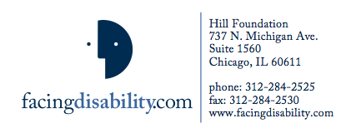

FOR IMMEDIATE RELEASE

FOR IMMEDIATE RELEASE
June 1. 2012

THEA FLAUM NAMED TO NATIONAL ADVISORY COMMITTEE

OF MODEL SYSTEMS KNOWLEDGE TRANSLATION CENTER

President of FacingDisability.com to develop new communication strategies

Thea Flaum, president and founder of FacingDisability.com, has been invited to serve on the National Advisory Committee of the Model Systems Translation Center (MSKTC).

The job of the Translation Center is to take the latest in research and news about diagnosis, treatment, rehabilitation and long-term quality of life for spinal cord injuries, traumatic brain injuries and burns and effectively communicate it to the world, so that it is useful both to the people with injuries and to those who treat them.

The Advisory Committee’s job is to develop user-friendly resources and products along with communication strategies that will get the word out.

The MSKTC is funded by the National Institutes on Disability and Rehabilitation Research (NIDRR), which is the federal program that funds major disability rehabilitation research at the 14 U.S. hospitals that are part of their Model Systems program.

Flaum created the highly acclaimed, ground-breaking FacingDisability.com website, which launched in 2011. The website features more than 1,000 videos of people with spinal cord injuries and their parents, spouses, siblings and children answering a series of questions about what they have learned from their own experiences. The questions are divided into such topics as “First Days After Spinal Cord Injury,” “Financial Issues,” “Relationships,” “Sex and Social Life after a Spinal Cord Injury.

The answers are short (most are no more than one-minute long) specific, personal and candid. All have been recorded in high-quality HD video. “Seeing and hearing the person who’s doing the talking makes for much better communication than just reading their words,” says Flaum,

The website was finded by the Hill Foundation for Families Living with Disabilities, is a 501(c )3 non-profit, based in Chicago. FacingDisability.com was specifically developed to connect families who suddenly have to deal with a spinal cord injury with the life experience of those who have gone before them.

Contact: Anne Hambleton
info@facingdisability.com, 312-284-2525

